1. Logo without the name

the name just below the logo as the Gmail App.

NSBSA below



The circle will be above then the name “NSBSA” will be below.

2. Login details:

Should default to member with a dropdown for another user called “Stokvel Chairman”

Email address:

Password:

Perhaps loggin using facebook?

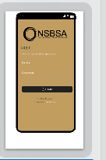

2. Change Insurance to “Funeral Cover”

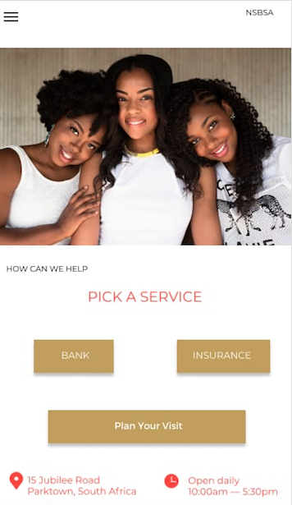

Include the following fields when one click on “Funeral Cover”

Status: Active/Lapsed/In Arrears (Must be visible, very bold).

If in Arrears, state the amount.

Monthly Premium:

Product: Family Cover, etc

Cover Amount: R3000.

Covered Members.

(Read Only).

Delete “Purchase Cover”

Bank:

Actual Bank Card -> redirect to another bank app (Retail Insight Cards APP). Please check if we can do that?

3. Agent leave it for now. We will check it later on

1. Admin

Data: Excel Spreadsheet would be updated and imported into the app on daily basis.